Unit 5 Study Guide: Human Sexuality and Reproduction
(Chapters 6-8, 16-18 and 25 in addition, Amplify Youth Development, Du Page County Health Department, Teen Parent Connection Information and in class power points, notes and discussions)
Give 3 Assertive Behaviors of Communication (chapter 6 lesson 3—pay attention to highlighted words)

What are 4 Red Flags of abuse in a relationship? (Chapter 9 lesson 4, In class and YWCA)

What is Oxytocin and what does it do? (Amplify Youth Development)
____________________________________________________________________________________________________________________________________________________________
What happens during each of the 3 trimesters? (video and Chapter 17 begins at p. 471-72 CHART)
TRIMESTER | MOM  What happens? | BABY  What happens?
First Trimester
Second Trimester
Third Trimester

How are Bacterial and Viral STDs different? (power-point, amplify, worksheet and 658-663)
____________________________________________________________________________________________________________________________________________________________
Give at least 2 examples of each type of STDs (sheet given in class, amplify and 658-663)
Bacterial: _______________ &_______________ Viral: ___________ and ________________

Match the appropriate definition to the letter on the diagrams: (Chapter 16, worksheet. F=453 and M=449)
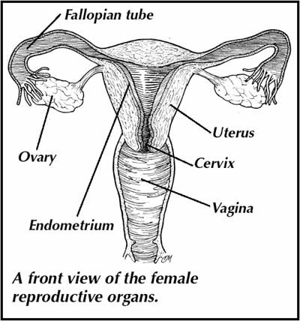
F
D
E
C
B
2) Uterus
3) Fallopian Tube
4) Vagina
5) Cervix
6) Ovary
7) Endometrium
A
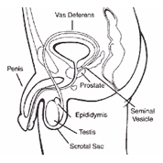
C
F
E
H
G
D
B
A
8) Penis
9) Epididymis
10) Urethra
11) Vas Deferens
12) Scrotum Sac
13) Testis
14) Prostate Gland
15) Seminal Vesicle

Male Reproductive Organ- Side View

The following Practice Test includes questions similar to those that will be asked on the test.
Good Luck Studying!

Practice Unit 5 Test
- Tom and Jenny work together and are also involved in a consensual relationship. Every day after lunch, Jenny walks over to Tom’s desk, rubs his back in a sensual way and makes sexual remarks to him. Albert, a co-worker who sits nearby, is witness to this and is highly offended by it. He rescheduled his lunch break so that he isn’t present when they return from their lunch. Albert eventually tells Tom that he finds this daily event to be disturbing and distracting. Tom apologized and he and Jenny immediately stop this behavior, never acting this way at work again. Two months later, Robert files a complaint about the past events. Is this sexual harassment?
- Yes

- No

- What is the most effective way to avoid STD’s, Pregnancy, Emotional Heartache and other problems? ______________________________________________________________________________________________________________________________________________________
GOVERNMENT WARNING:
- ACCORDING TO THE SURGEON GENERAL. WOMEN SHOULD NOT DRINK ALCOHOLIC BEVERAGES DURING PREGNANCY BECAUSE OF THE RISK OF __________________________.
- CONSUMPTION OF ALCOHOLIC BEVERAGES IMPAIRS YOUR ________ TO DRIVE A CAR OR OPERATE HEAVY MACHINERY AND MAY CAUSE ___________________________

a) Birth defects, ability, health problems
b) Memory problems, ability, happiness
c) Cancer, chances, blindness

- What are the 4 ways STD’s spread?
a.
b.
c.
d.
- How should the foundation of your relationship be in terms of your personality?

a) It improves me as a person, it is constructive, and others notice a positive effect of my life

b) I feel incredible highs and lows, I think about him/her all the time

“Juanita began feeling very nauseous and her breast became very tender. She has vomited the last two mornings and has gained a few pounds. She has been craving pickles and peanut butter too. She has also been having some mood swings and feeling very emotional lately.”
6) After reading this, we can assume the Juanita could?
a) Be ill b) Be pregnant c) Have heart disease d) Have cancer
7) When making a decision, you should keep the following guidelines in your head: “ is it safe, is it
legal, does it respect you and others, is it healthy & does it respect my parents/guardians guidelines.”

- True b) False

8) Body Systems: Fill in the Blank
________________________ A) Pumps blood to all parts of the body
________________________ B) provides the body's means of transforming food to energy
________________________ C) uses hormones to stimulate the metabolic activities of the cells
________________________ D) the body’s main defense against all foreign substances
________________________ E) protects from underlying layers from sun & temperature regulation
________________________ F) helps us move, made up of muscles,
________________________ G) master controlling and communicating system of the body
________________________ H) supplies the body with oxygen
________________________ I) filtering out wastes and purifying blood
________________________ J) allows for the continuation of the human species
________________________ K) supports us and gives us our shape, made up of cartilage and bone

9) Identify the 5 dimensions of wellness and how are they inter-related?

